1. JUnit_Basic Testing Exercises

Exercise 1: Setting Up JUnit
Adding Dependencies in Pom.xml :
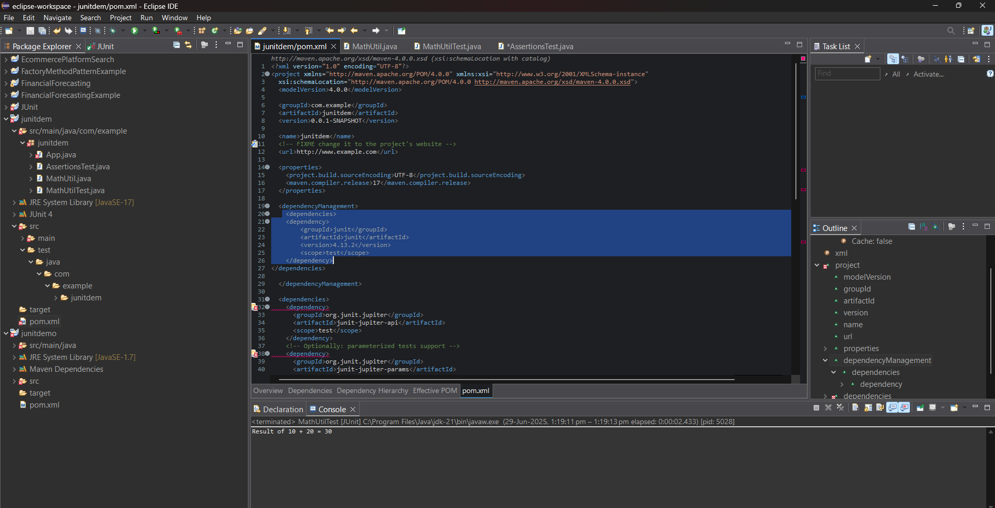

MathUtil.java :
package junitdem;
public class MathUtil {
public int add(int a, int b) {
return a + b;
}
}

MathUtilTest.java :
package junitdem;
import org.junit.Test;
import static org.junit.Assert.assertEquals;

public class MathUtilTest {

@Test
public void testAdd() {
MathUtil math = new MathUtil();
int result = math.add(10, 20);
System.out.println("Result of 10 + 20 = " + result);
assertEquals(30, result);
}
}

OUTPUT:
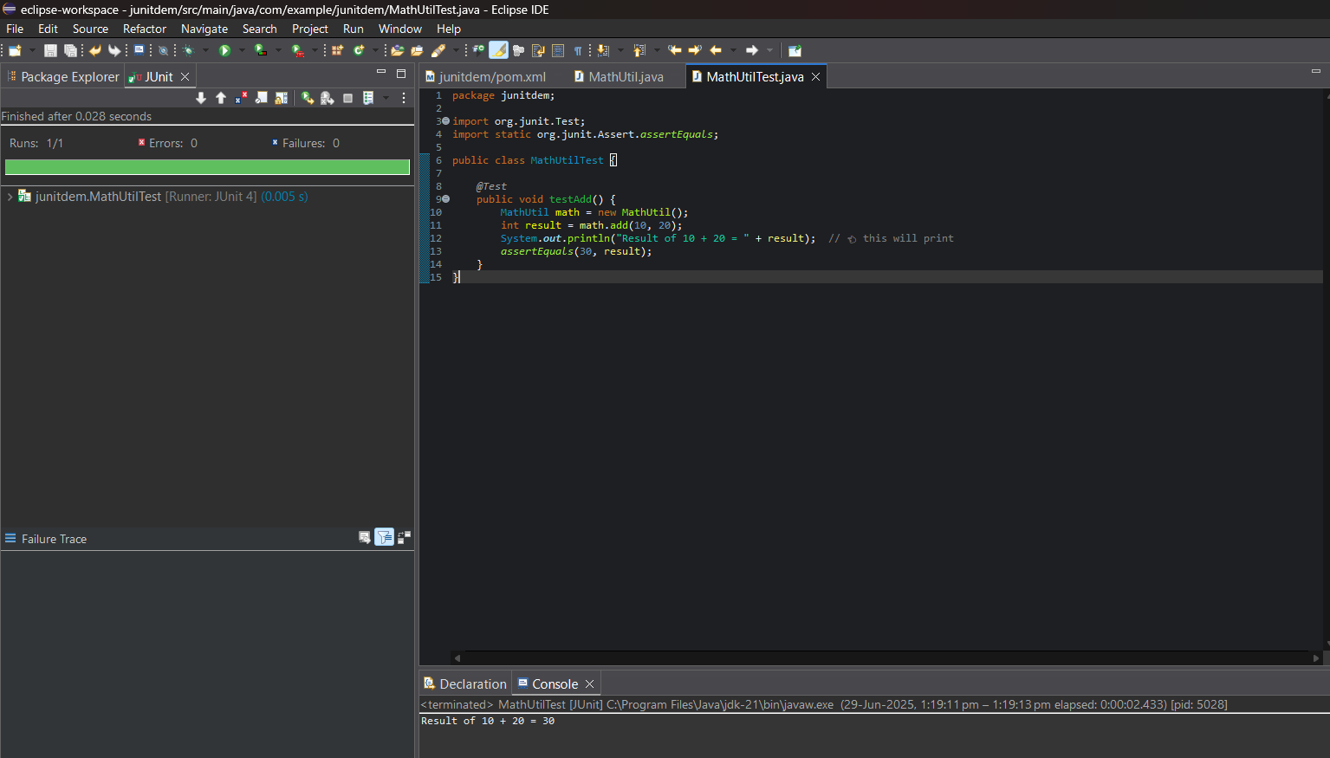

Exercise 3: Assertions in JUnit

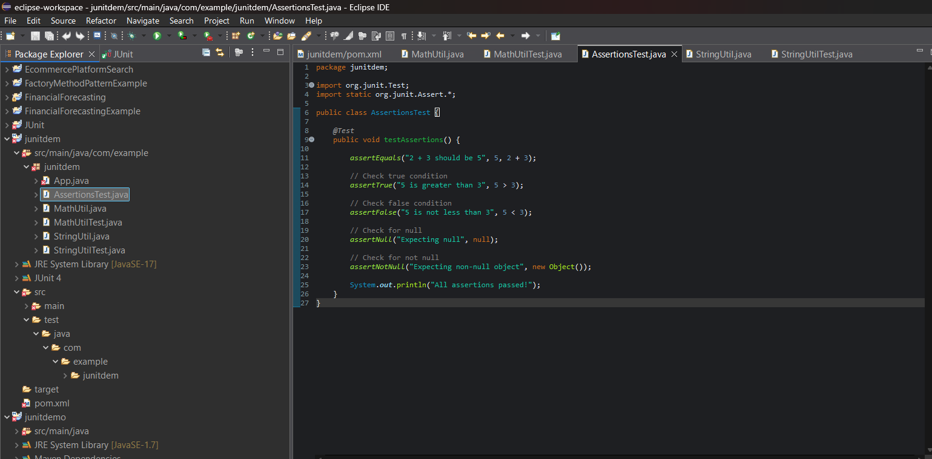

AssertionsTest.java :
package junitdem;
import org.junit.Test;
import static org.junit.Assert.*;

public class AssertionsTest {

@Test
public void testAssertions() {
assertEquals("2 + 3 should be 5", 5, 2 + 3);

// Check true condition
assertTrue("5 is greater than 3", 5 > 3);

// Check false condition
assertFalse("5 is not less than 3", 5 < 3);

// Check for null
assertNull("Expecting null", null);

// Check for not null
assertNotNull("Expecting non-null object", new Object());

System.out.println("All assertions passed!");
}
}

OUTPUT:
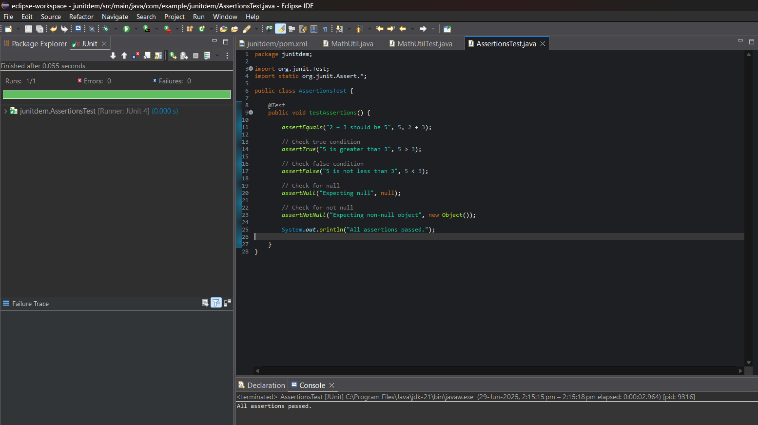

Exercise 4: Arrange-Act-Assert (AAA) Pattern, Test Fixtures, Setup and Teardown Methods in JUnit

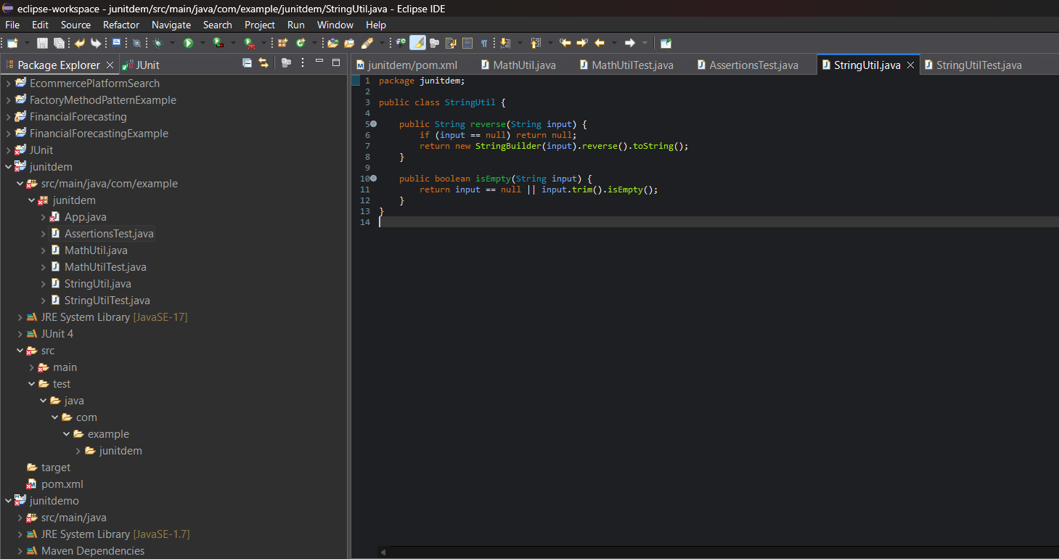

StringUtil.java :
package junitdem;
public class StringUtil {
public String reverse(String input) {
if (input == null) return null;
return new StringBuilder(input).reverse().toString();
}
public boolean isEmpty(String input) {
return input == null || input.trim().isEmpty();
}
}
StringUtilTest.java :
package junitdem;

import org.junit.Before;
import org.junit.After;
import org.junit.Test;
import static org.junit.Assert.*;

public class StringUtilTest {

private StringUtil stringUtil;

@Before
public void setUp() {
System.out.println("Setting up...");
stringUtil = new StringUtil();
}

@After
public void tearDown() {
System.out.println("Cleaning up...");
stringUtil = null;
}

@Test
public void testReverse() {
String result = stringUtil.reverse("hello");
assertEquals("olleh", result);
}

@Test
public void testReverseNull() {
String result = stringUtil.reverse(null);
assertNull(result);
}

@Test
public void testIsEmpty_True() {
assertTrue(stringUtil.isEmpty(" "));
}

@Test
public void testIsEmpty_False() {
assertFalse(stringUtil.isEmpty("OpenAI"));
}
}

OUTPUT:
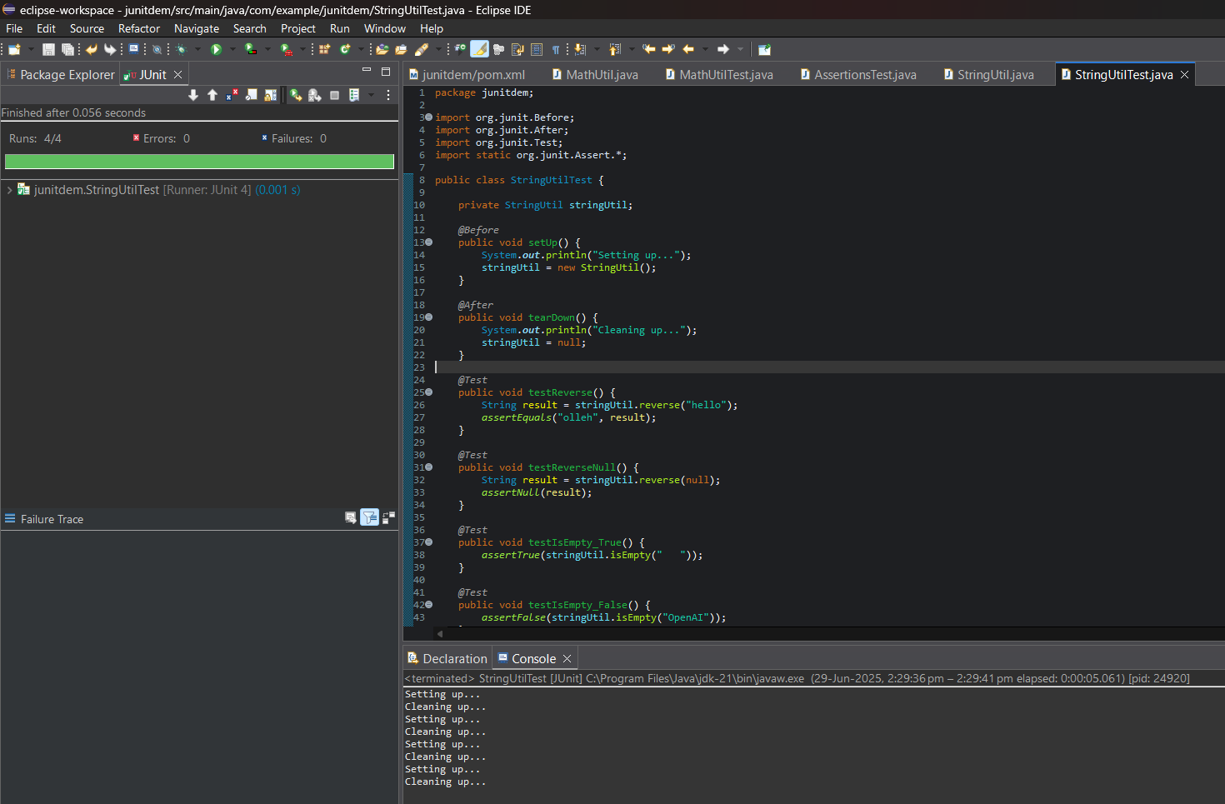

3. Mockito exercises

Exercise 1: Mocking and Stubbing from Scratch

Adding Dependencies to Pom.xml :
<dependencies>
<!-- JUnit 5 API -->
<dependency>
<groupId>org.junit.jupiter</groupId>
<artifactId>junit-jupiter-api</artifactId>
<version>5.11.0</version>
<scope>test</scope>
</dependency>

<!-- JUnit 5 Engine (required to run tests) -->
<dependency>
<groupId>org.junit.jupiter</groupId>
<artifactId>junit-jupiter-engine</artifactId>
<version>5.11.0</version>
<scope>test</scope>
</dependency>

<!-- Mockito Core -->
<dependency>
<groupId>org.mockito</groupId>
<artifactId>mockito-core</artifactId>
<version>5.12.0</version>
<scope>test</scope>
</dependency>
</dependencies>

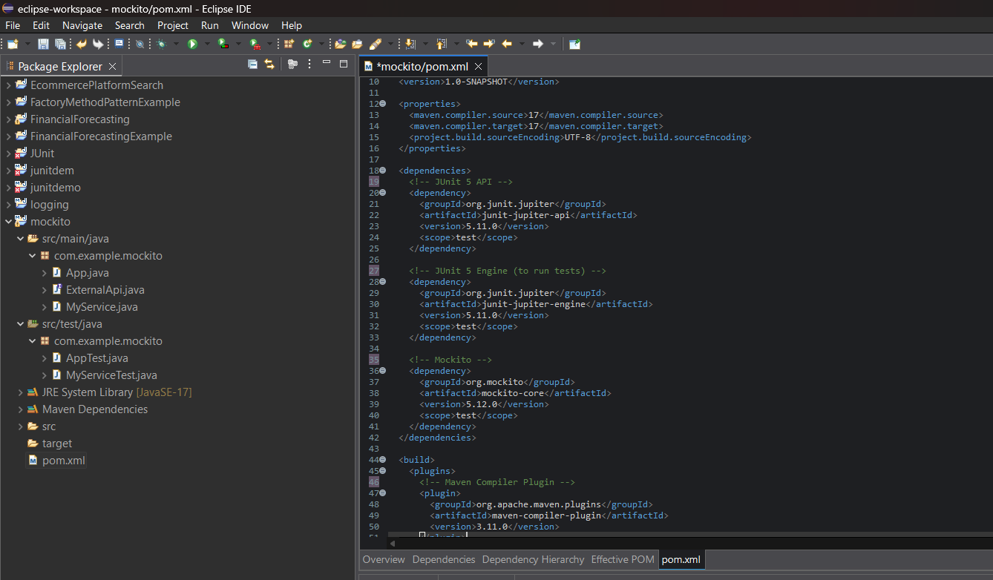

ExternalApi.java :
package com.example.mockito;
public interface ExternalApi {
String getData();
}

MyService.java :
package com.example.mockito;
public class MyService {
private final ExternalApi api;

public MyService(ExternalApi api) {
this.api = api;
}

public String fetchData() {
return api.getData();
}
}

MyServiceTest.java :
package com.example.mockito;

import static org.mockito.Mockito.*;
import static org.junit.jupiter.api.Assertions.*;
import org.junit.jupiter.api.Test;

public class MyServiceTest {

@Test
public void testExternalApi() {

ExternalApi mockApi = mock(ExternalApi.class);
when(mockApi.getData()).thenReturn("Mock Data");
MyService service = new MyService(mockApi);
String result = service.fetchData();
assertEquals("Mock Data", result);
}
}

OUTPUT:
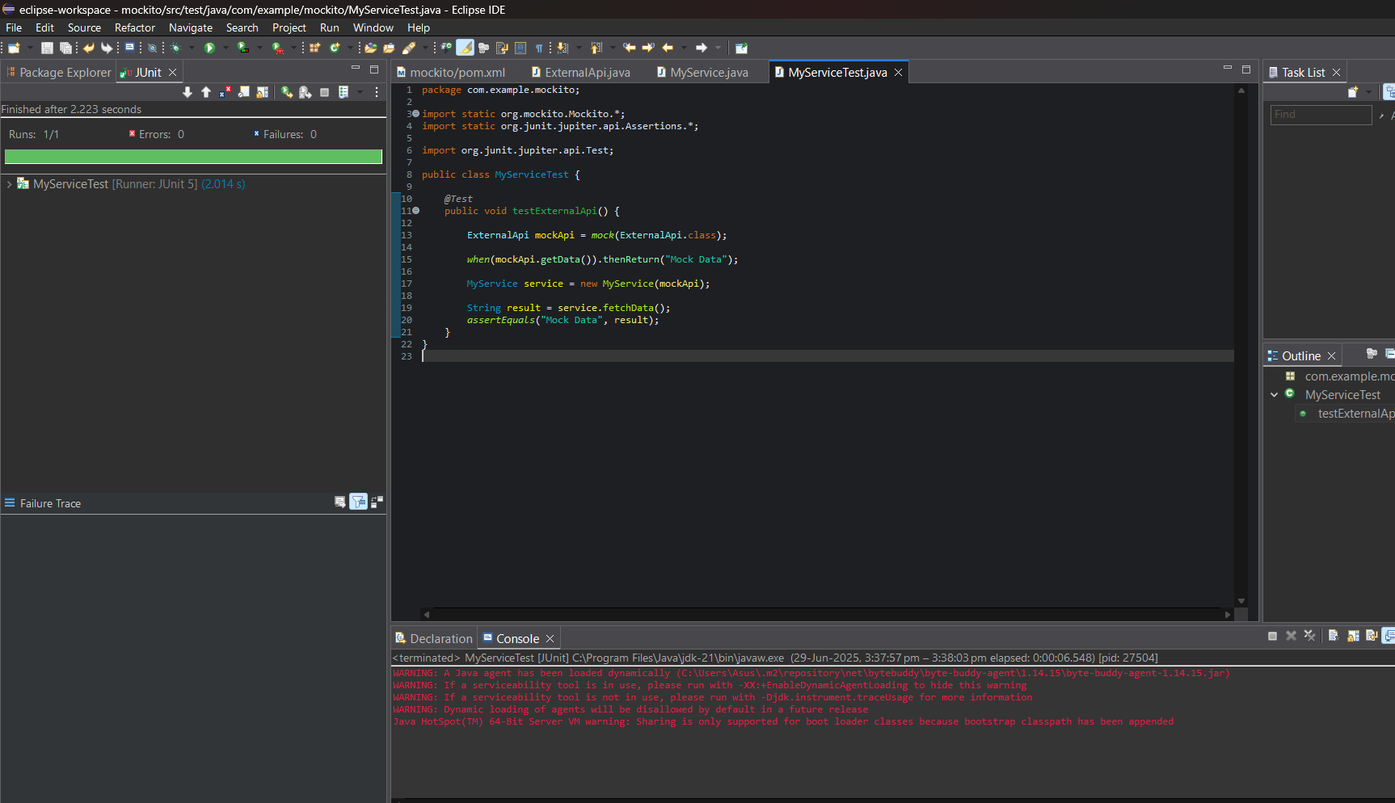

Exercise 2: Verifying Interactions

ExternalApi.java :
package com.example.mockito;
public interface ExternalApi {
String getData();
}

MyService.java :
package com.example.mockito;
public class MyService {
private final ExternalApi api;

public MyService(ExternalApi api) {
this.api = api;
}

public String fetchData() {
return api.getData();
}
}

MyServiceTest.java :
package com.example.mockito;
import static org.mockito.Mockito.*;
import org.junit.jupiter.api.Test;

public class MyServiceTest {

@Test
public void testVerifyInteraction() {

ExternalApi mockApi = mock(ExternalApi.class);

MyService service = new MyService(mockApi);
service.fetchData();

verify(mockApi).getData();
}
}
OUTPUT:
